For Internal Use
SDGs Design International Awards 2023 Entry Form
(For your Prefered Language if any)

Applicant’s Particulars (Individual or Group Entry) Arial Font Size 9
Given Name  (for Group Entry, representative name only) |  | Surname |  | Group Member Name(s)  (if any)
Name of Educational Institution |  | Faculty/Division  (if any) |  | Email Address  (for Group Entry, representative email address only)
Contact Number  (Please indicate the country code and area code) |  | Home Address
Select the theme of your choice (1 or 2), and place a "✓" in the box provided.
Theme : Let’s Create Sustainable Future Design for Children!
Theme 1: Select ONE topic from the list below. |  |  |  |  | Theme 2: Select ONE topic.  □ Topic 1 □ Topic 2  □ Topic 3
□ Children and Medical Care  □ Children and Culture | □ Children and Education  □ Children and Natural Disasters |  | □ Children and Diverse Families  □ Bully-free and Violence-free Society |  | □ Topic1 KM Biologics Award  □ Topic2 Yuko Lucky Group Award
Title (Arial Font Size 9)
Summary (Aim, Target User, Appealing Points or Innovation) (Arial Font Size 9, Max 300 words)
Background Evidence (Arial Font Size 9, Max 150 words)
Anticipate Results (Social Impact) (Arial Font Size 9, Max 150 words)
IMPORTANT:

Please read the following rules carefully and adhere to the rules:
- Enter your entry content only in the space provided on the left-hand side. Do not write anything on this side of the page.
- Use the stated font type and font size.
- The application form for themes 1 and 2 cannot exceed two A3 pages.
- Do not write more than the allowed number of words for each section.
Applicants who do not adhere to the rules can be DISQUALIFIED.

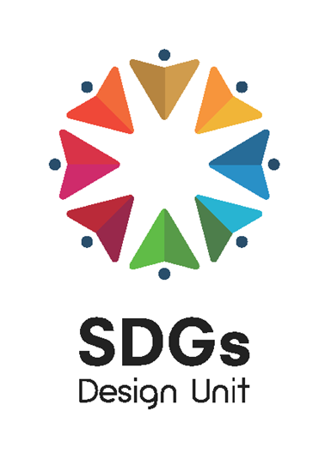

If you are not confident about writing the entry form in English, we recommend using the free translation app, DeepL.
https://www.deepl.com/ja/translator

Design (Express your idea as text, figures, illustrastions, or images)

